mysql 函数 Cannot load from mysql.proc.

听语音

* |
* 浏览：14
* |
* 更新：2016-08-17 14:37
* [](http://jingyan.baidu.com/album/25648fc192fab99190fd0049.html?picindex=1)1
* [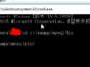](http://jingyan.baidu.com/album/25648fc192fab99190fd0049.html?picindex=2)2
* [](http://jingyan.baidu.com/album/25648fc192fab99190fd0049.html?picindex=3)3
* [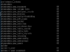](http://jingyan.baidu.com/album/25648fc192fab99190fd0049.html?picindex=4)4

[分步阅读](http://jingyan.baidu.com/album/25648fc192fab99190fd0049.html)

MYSQL ERROR 1728 (HY000): Cannot load from mysql.proc. The table is probably corrupted

工具/原料

* cmd

方法/步骤

1. 运行-》cmd

[](http://jingyan.baidu.com/album/25648fc192fab99190fd0049.html?picindex=1)

1. cd 到mysql目录 bin

[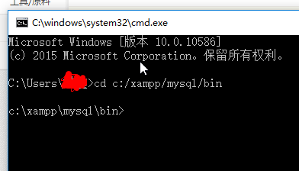](http://jingyan.baidu.com/album/25648fc192fab99190fd0049.html?picindex=2)

1. 输入 ：mysql_upgrade.exe -uroot -p --force

[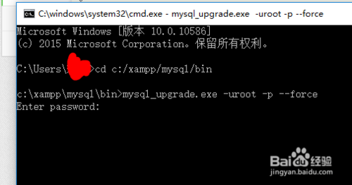](http://jingyan.baidu.com/album/25648fc192fab99190fd0049.html?picindex=3)

1. 输入数据库密码

[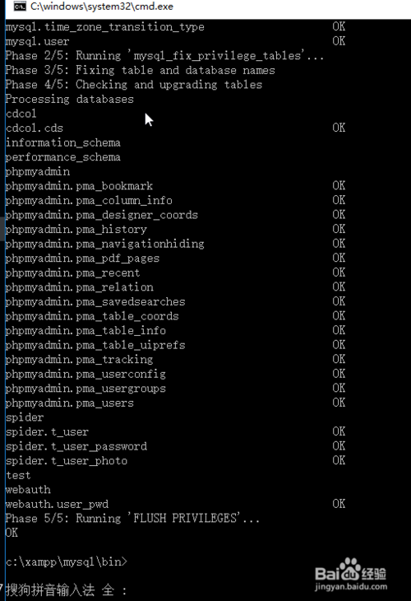](http://jingyan.baidu.com/album/25648fc192fab99190fd0049.html?picindex=4)